**DATA PREPROCESSING AND ANALYSIS FOR DATASET**

**USING WEKA**

**DESCRIPTION :**

Consider a dataset of traveltimes.csv file where it contains the columns of (or) attributes as Date, StartTime, DayOfWeek, GoingTo, Distance, MaxSpeed, AvgSpeed, AvgMovingSpeed, FuelEconomy, TotalTime, MovingTime, Take407All comments.



PREPROCESS :

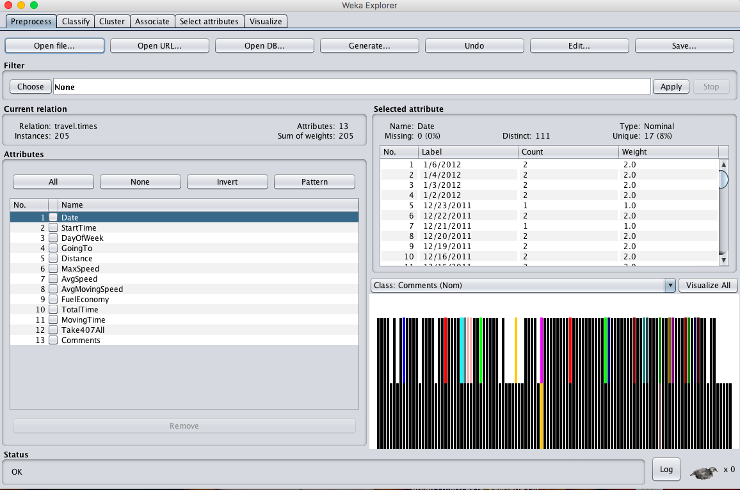

**OBSERVATION :**

1. **ATTRIBUTE TYPE :**

|  |  |  |
| --- | --- | --- |
| **S.NO** | **ATTRIBUTE** | **TYPE** |
|  | Date | Nominal |
|  | Start Time | Nominal |
|  | Day Of Week | Nominal |
|  | Going To | Nominal |
|  | Distance | Numeric |
|  | Max Speed | Numeric |
|  | Avg Speed | Numeric |
|  | Avg Moving Speed | Numeric |
|  | Fuel Economy | Nominal |
|  | Total Time | Numeric |
|  | Moving Time | Numeric |
|  | Comments | Nominal |
|  | Take 407 All | Nominal |

1. **PERCENTAGE OF MISSING VALUES :**

|  |  |  |
| --- | --- | --- |
| **S.NO** | **ATTRIBUTE** | **Percentage Of Missing Values** |
|  | Date | 0 % |
|  | Start Time | 0 % |
|  | Day Of Week | 0 % |
|  | Going To | 0 % |
|  | Distance | 0 % |
|  | Max Speed | 0 % |
|  | Avg Speed | 0 % |
|  | Avg Moving Speed | 0 % |
|  | Fuel Economy | 8 % |
|  | Total Time | 0 % |
|  | Moving Time | 0 % |
|  | Comments | 88 % |
|  | Take 407 All | 0 % |

1. **MIN, MAX, MEAN, STANDARD DEVIATION :**

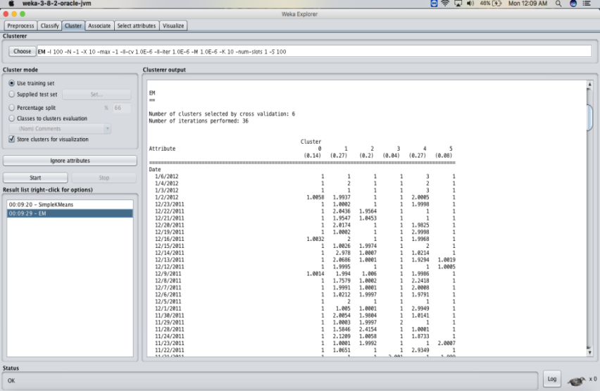

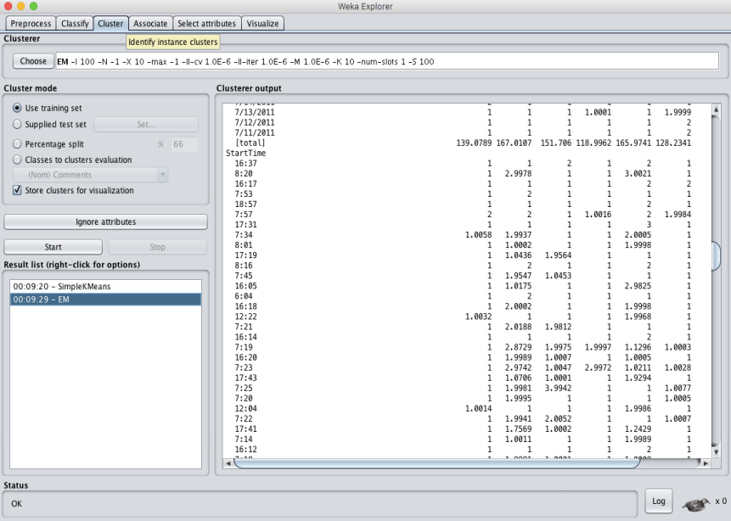

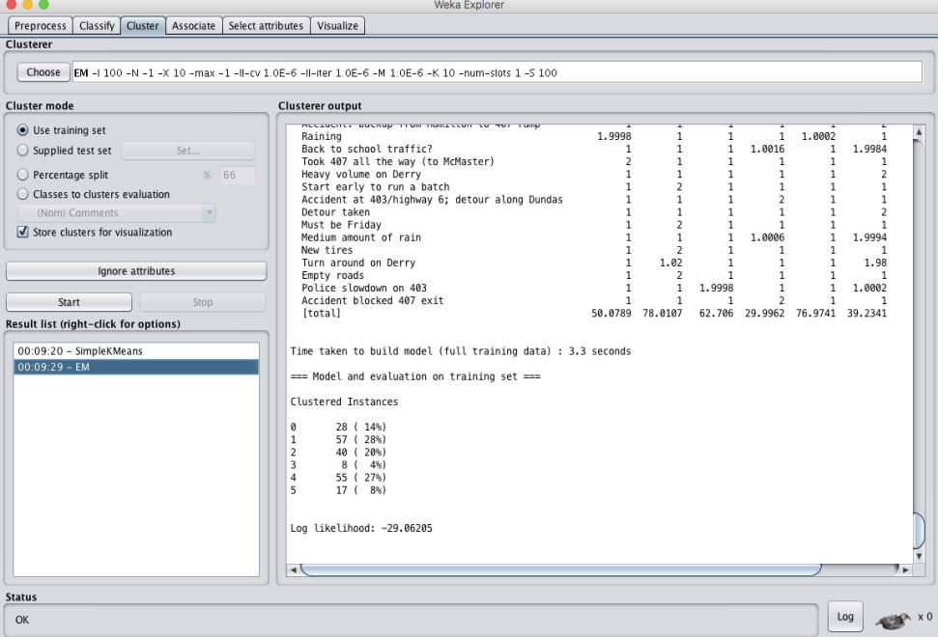

**RESULT :**

Thus, the dataprocessing and analysis for a dataset using weka tool has been successfully completed.